Plant Disease Detection for Smart Agriculture
Mrs. Y. Roji¹, E. Sai Prasad², B. Sai Pavani³, B. Anusha⁴
¹ Assistant Professor, Dept. of Electronics and Communication Engineering, Vignana Bharathi Institute of Technology, Telangana, India
^{2,3,4} Students, Final Year, Department of Electronics and Communication Engineering, Vignana Bharathi Institute of Technology, Telangana, India

---------------------------------------------------------------------***---------------------------------------------------------------------

Abstract - The main aim of this project is to detect plant diseases by smart agriculture. Smart farming is a big leap from traditional farming as it brings certainty and predictability to the table. Robotics, automation, and cloud software systems are tools for smart farming. Robotics, drones and sensor equipment placed throughout the farms can collect data and this data is processed to produce farm insight. This project would simplify plant monitoring process and reduce human efforts drastically. User can create customized environment for the plants. By detecting the infected plant by monitoring it based on wireless sensor network design we can easily identify the infected part of the plant its shape and color and take the necessary precautions. This project gives the executed results on different diseases classification techniques that can be used for plant leaf disease detection. Software like Machine learning, python, Raspberry pi operating system along with some algorithms like Random Forest classifier and hist gradient boosting classifier are used in order to detect the plant diseases. Blynk server is used because it can control hardware remotely, it can display sensor data, it can store data, visualize it
Key Words: Raspberry Pi, Arduino Nano, NRF24L01+, ESP8266, OPEN CV, Machine Learning

1. INTRODUCTION

An integration of plant monitoring with image processing sensor networks is the new method. The results show the advantages of new technology in terms of reduced power consumption and area reduction. It can help the farmer to detect the plant conditions faster. The wireless system also improves the farmer-field-expert relationship. Among all these technologies, the agriculture domain is mostly explored concerning the application of WSNs in improving the traditional methods of farming. The ubiquitous nature of operation, together with self-organized small sized nodes, scalable and cost-effective technology, enables the WSNs as a potential tool towards the goal of automation in plant monitoring system. However, WSNs have few limitations such as low battery power, limited computation capability and small memory of the sensor nodes. These limitations invite challenges in the design of WSN applications in plant monitoring systems. In plant monitoring systems, most of the WSN-based applications are targeted for various applications. For example, WSNs for environmental condition monitoring with information of soil nutrients is applied for predicting crop health and production quality over time. Irrigation scheduling is predicted with WSNs by monitoring the soil moisture and weather conditions. Being scalable, the performance of an existing WSN-based application can be improved to monitor more parameters by only including additional sensor nodes to the existing architecture. However, challenges may emerge from the choice of the deployment region. The term smart agriculture refers to the usage of technologies like Internet of Things, sensors, location systems, robots and artificial intelligence on your farm. If we were to take a look at the future, there are already a few trends that are transforming agriculture globally. Enhanced hybridization: The use of hybrid seeds enables better heterosis in non-favorable soil and climatic conditions such as saline soils and rain fed ecosystems.

1.1 Proposed System

This project would simplify plant monitoring process and reduce human efforts drastically. User can create customized environment for the plants. By detecting the infected plant by monitoring it based on wireless sensor network design we can easily identify the infected part of the plant, its shape, color and take the necessary precautions. This project gives the executed results on different diseases classification techniques that can be used for plant leaf disease detection.
The advancement in inventive farming techniques is gradually enhancing the crop yield making it more profitable and reduces irrigation wastages. The proposed model is a smart irrigation system that detects the disease using a machine learning algorithm.
1.2 Objective

Our main objective is to detect any kind of plant diseases by using Arduino ide and machine learning by implementing certain algorithms and using IoT cloud storage. The goal of smart agriculture research is to ground a decision-making support system for farm management. Smart farming deems it necessary to address the issues of population growth, climate change, and labor that have gained a lot of technological attention, from planting and watering crops to health and harvesting. Image processing for smart farming: Detection of disease and fruit grading. In this project image processing is used as a tool to monitor the diseases on fruits during farming, right from plantation to harvesting. Detection of diseases in the plant is of utmost need for farmers and agricultural experts. The main aim of the proposed system is to detect plant diseases using IoT.

2. METHODOLOGY

Integration of plant monitoring with image processing sensor networks is the new method. The results show the advantages of new technology in terms of reduced power consumption and area reduction. It can help the farmer to detect the plant conditions faster. The wireless system also improves the farmer-field-expert relationship.

The proposed model is a smart irrigation system that predicts diseases using a machine learning algorithm. Decision tree algorithm and efficient machine learning algorithm are applied to the data sensed from the field in to predict results efficiently. The algorithms we used in this system are Random Forest classifier and Histogram gradient boosting classifier. Here software used in Arduino ide, Machine learning, Python, Raspberry Pi OS.
Machine learning algorithms are used in a wide variety of applications, such as in medicine, email filtering, and computer vision, where it is difficult or unfeasible to develop conventional algorithms to perform the needed tasks. A subset of machine learning is closely related to computational statistics, which focuses on making predictions using computers; but not all machine learning is statistical learning.
The study of mathematical optimization delivers methods, theory and application domains to the field of machine learning. Data mining is a related field of study, focusing on exploratory data analysis through unsupervised learning. In its application across business problems, machine learning is also referred to as predictive analytics.
The two algorithms used are:
- Random forest classifier
- Histogram gradient boosting classifier

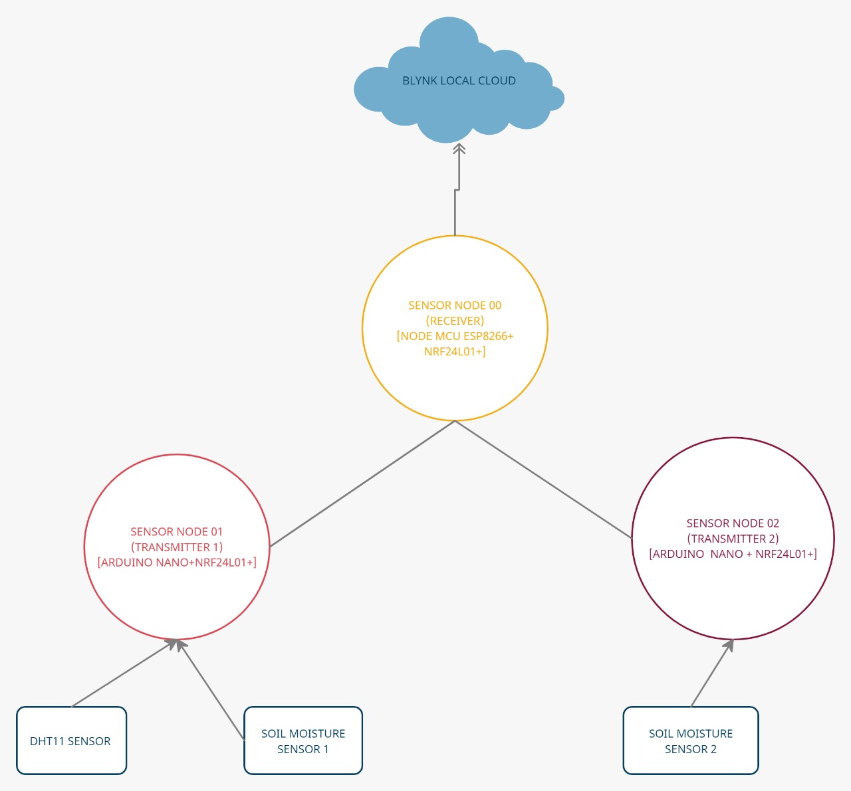
FIG-1: Block Diagram

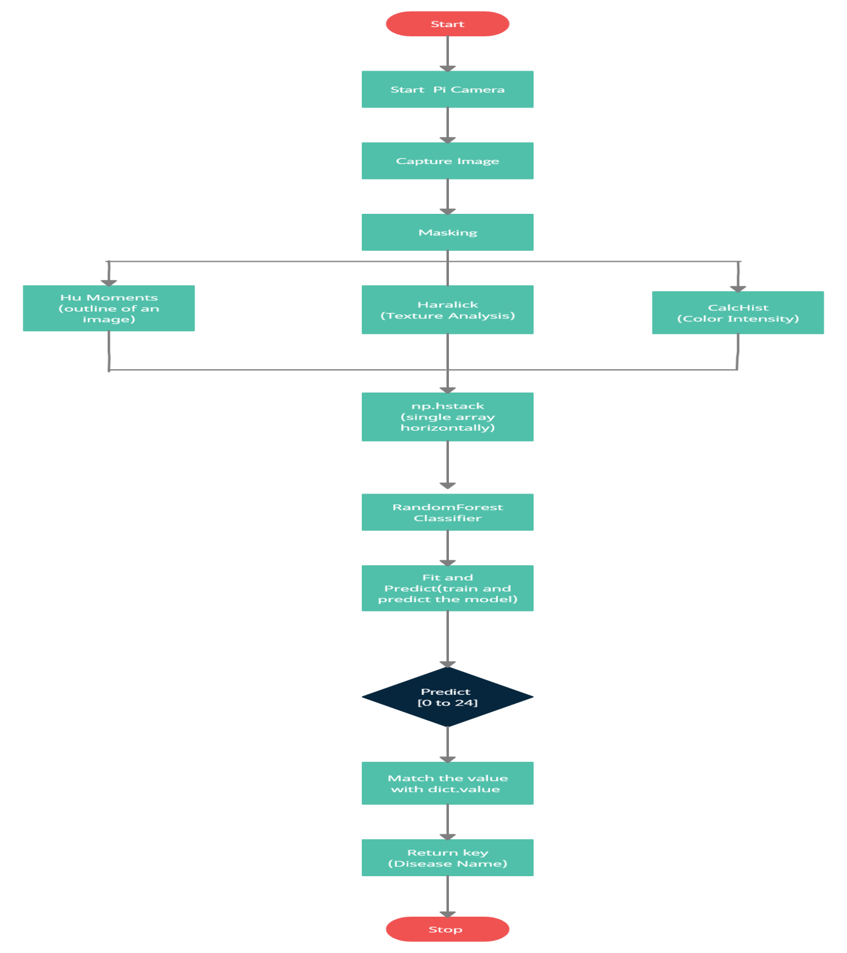

FIG-2: Flow Chart

3. HARDWARE AND SOFTWARE REQUIREMENTS

3.1 Hardware Requirements:

- Raspberry pi 4 model B
- Dht11 sensor
- Soil moisture sensors
- Camera Module
- Arduino NANO
- Esp8266
- Nrf24l01
- Jumper wires
- Bread Board

3.2 Software Requirements:
- Arduino ide
- Machine learning
- Python
- Raspberry pi OS

Packages:
- Rf24
- Esp8266
- Dht11
- Open cv
- Mahotas
- H5py
- Matplot lib
- Job lib

4. RESULT

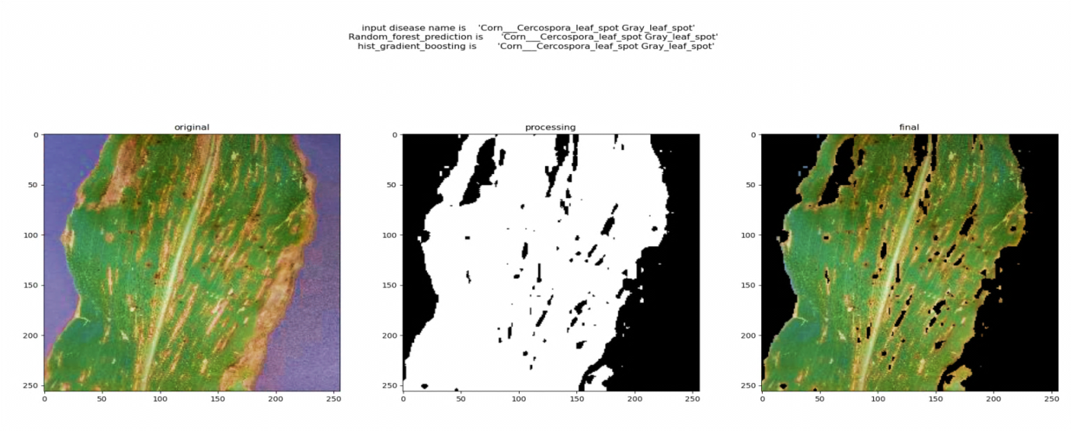
FIG-3: Corn Cersospora Gray leaf spot

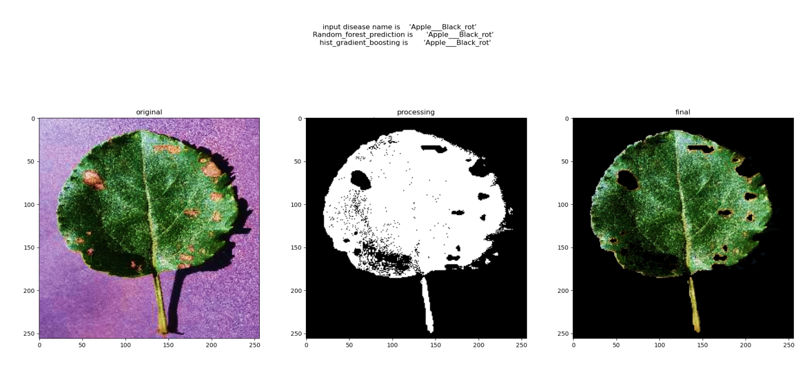

FIG-4: Apple Black rot

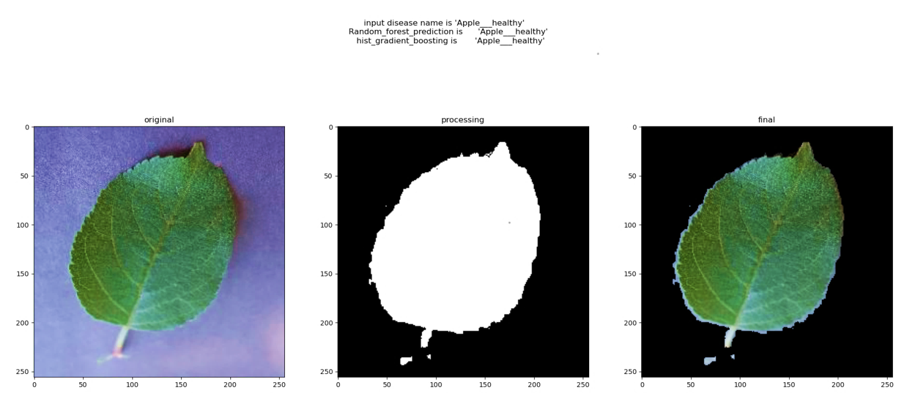

FIG-5: Apple Healthy Leaf

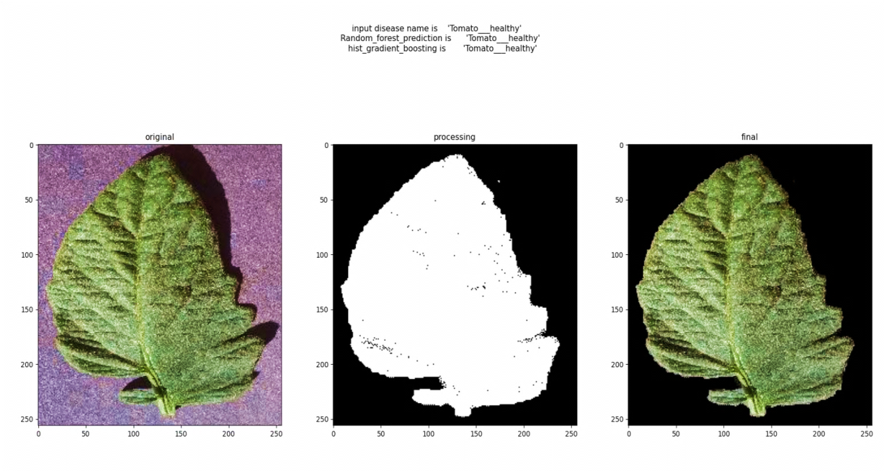

FIG-6: Tomato Healthy Leaf

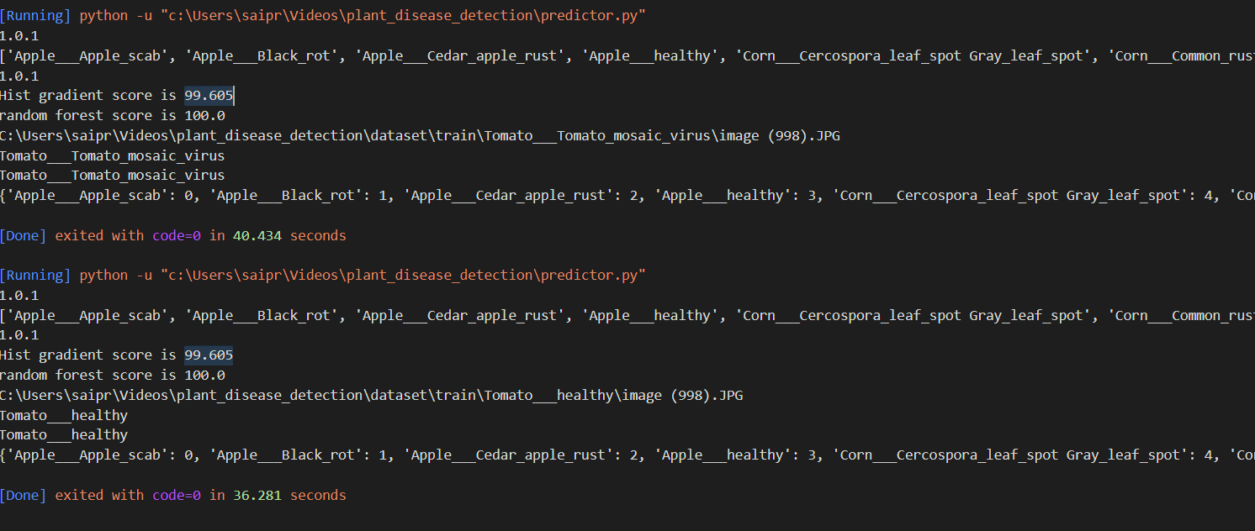

FIG-7: Prediction and Detection

Random Forests are a general class of ensemble building methods that use a decision tree as the base classifier. The Random Forest classifier is a variation of the Bagging classifier (Bootstrap Aggregating). The Bagging algorithm is a method of classification that generates weak individual classifiers using bootstrap. Each classifier is trained on a random redistribution of the training set so that many of the original examples may be repeated in each classification. It is a method for classification, regression, and some kinds of prediction. The method is based on the decision tree definition as a binary tree-like graph of decisions and possible consequences.
Random Forest, like its name implies, consists of a large number of individual decision trees that operate as an ensemble. Each individual tree in the random forest spits out a class prediction and the class with the most votes becomes our model’s prediction. While some trees may be wrong, many other trees will be right, so as a group the trees are able to move in the correct direction. So the prerequisites for random forest to perform well are:

- There needs to be some actual signal in our features so that models built using those features do better than random guessing.
- The predictions (and therefore the errors) made by the individual trees need to have low correlations with each other.
- Ensuring that the Models Diversify Each Other

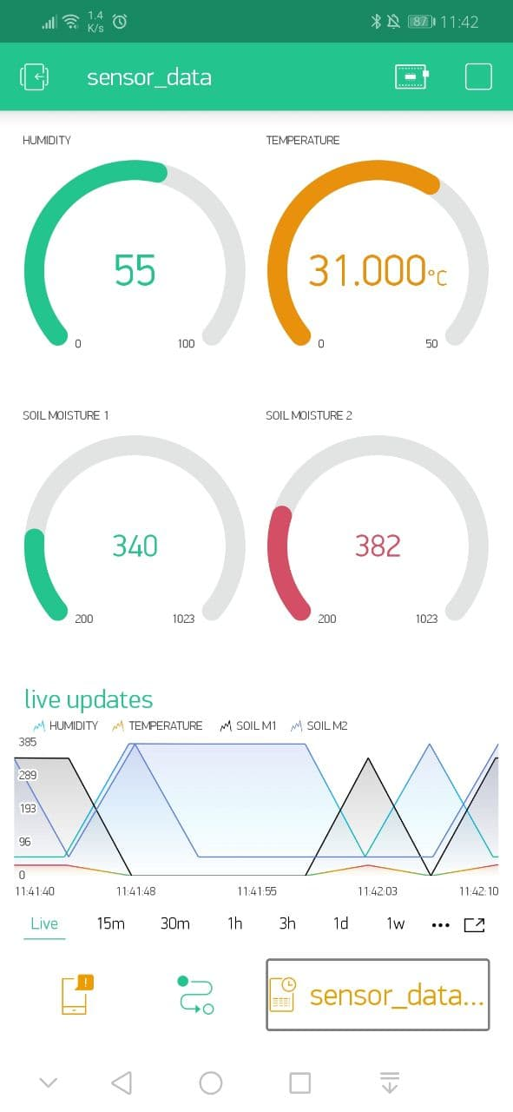

FIG-8: Sensor Data

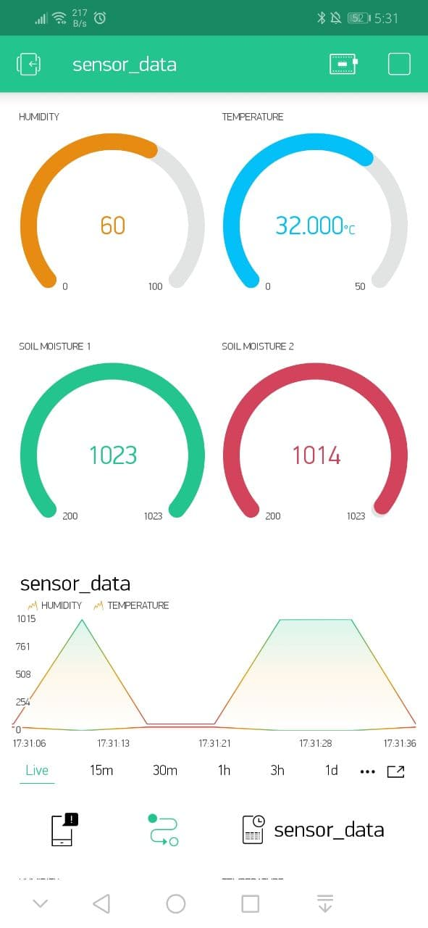

FIG-9: Sensor Data

5. CONCLUSION
In this project an image feature extraction and processing approach is proposed and used for infected area detection. We test our program on a leaf and get the results of affected area, precision and accuracy. Our experimental results show that the proposed approach can support accurate and automatic detection of percentage of affected area and the type of disease the plant is affected with.
We have developed a functional prototype of plant monitoring system which is capable of detecting the plant diseases. The final product is a device that can be placed in an agriculture land in different places reading the soil moisture, humidity of the soil and the temperature of the surrounding.
6. FUTURE SCOPE
- Future scope can be the need to compute amount of disease preset on leaf. Future work can be developed in hybrid algorithm and NNS in order to improve the recognition rate of final classification process.
- Detection of nitrogen, phosphorus and potassium (NPK) nutrients of soil using Soil NPK sensor for fertility degree testing in agricultural greenhouse.
- Design and Development of a Drone for Spraying Pesticides, Fertilizers and Disinfectants
- Inspired by the work of plantvillage.psu.edu and iita.org, we wanted to use the rover platform to build an autonomous robot that can move in a farm environment without damaging existing plants or soil and use object detection to find and mark diseased crops with an environmentally safe color.

REFERENCES
- "Architecture Design of the Internet of Things based on Cloud Computing." In Measuring Technology and Mechatronics Automation, 20 15 Seventh International Conference on, pp. 206-209. IEEE, 2015.

- “Image Processing in agriculture.” IJIREEICE Vol. 2, Issue 6, June 2014.

- International research journal of Engineering and Technology (IRJET)

- Internet-of-Things (IoT)-Based Smart Agriculture: Toward Making the Fields Talk, IEEE Access (Volume: 7), 01 August 2019.

